Assignment 3 : Retrieve data using Group By clause

-------------------------------------------------------------------------------------------------------------

Sample table1:Department

-dept_id

-dept_name

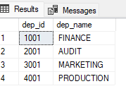

Sample table2: Employee

-emp_id

-dept_id

-mngr_id

-emp_name

-salary

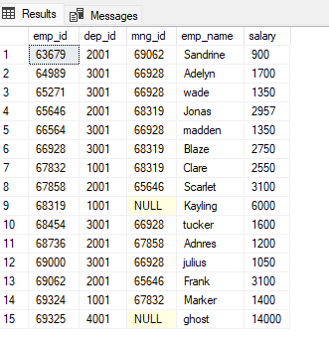

1. write a SQL query to find Employees who have the biggest salary in their Department

--Query1

select e.emp_name, d.dep_name, e.salary from employee as e left join department as d on e.dep_id=d.dep_id where e.salary in (select max(salary) from employee group by dep_id);

Output:

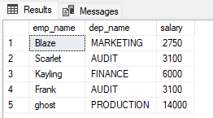

2. write a SQL query to find Departments that have less than 3 people in it

--Query2

select Count(e.dep_id), d.dep_name from employee e left join department d on e.dep_id=d.dep_id group by d.dep_name having count(e.dep_id)<3

Output:

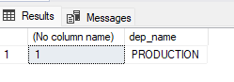

3. write a SQL query to find All Department along with the number of people there

--Query3

select Count(e.emp_name) as no_of_employee, d.dep_name from employee e left join department d on e.dep_id=d.dep_id group by d.dep_name

Output:

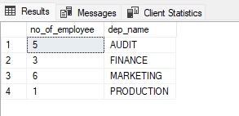

4. write a SQL query to find All Department along with their total salary

--Query4

select sum(e.salary) as total_salary, d.dep_name from employee e left join department d on e.dep_id=d.dep_id group by d.dep_name

